Hist 1671 Office Hours:
Professor James N. Green Tues. 1:00-2:00, 130 Angell St., Rm. 104
Tues/Thur: 2:30-3:50 Wed., 10:00-11:00 Watson Institute, Rm. 215
Kassar House FOX Office phone: (401) 863-1394
James_Green@brown.edu

Brazil: From Abolition to Emerging Global Power

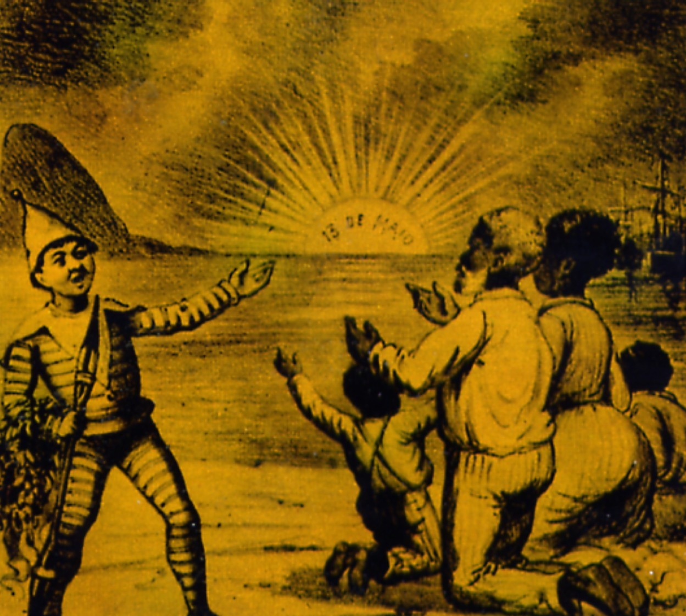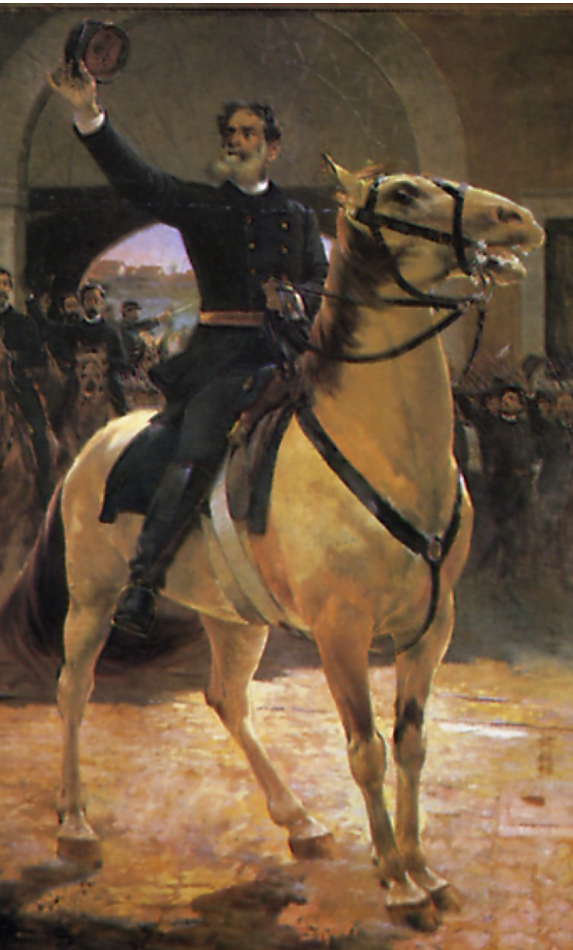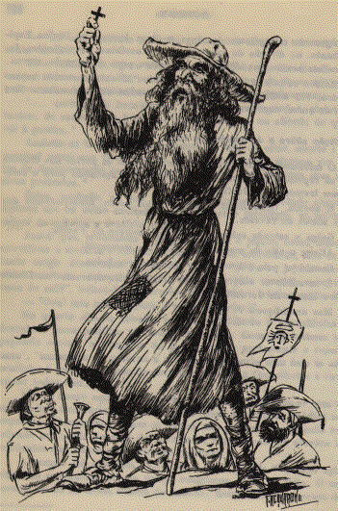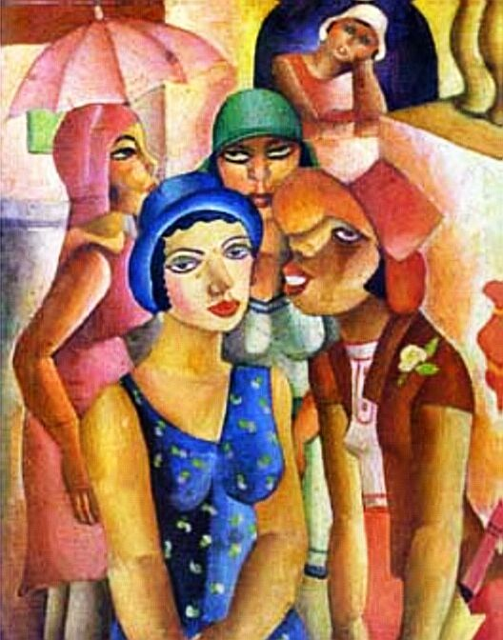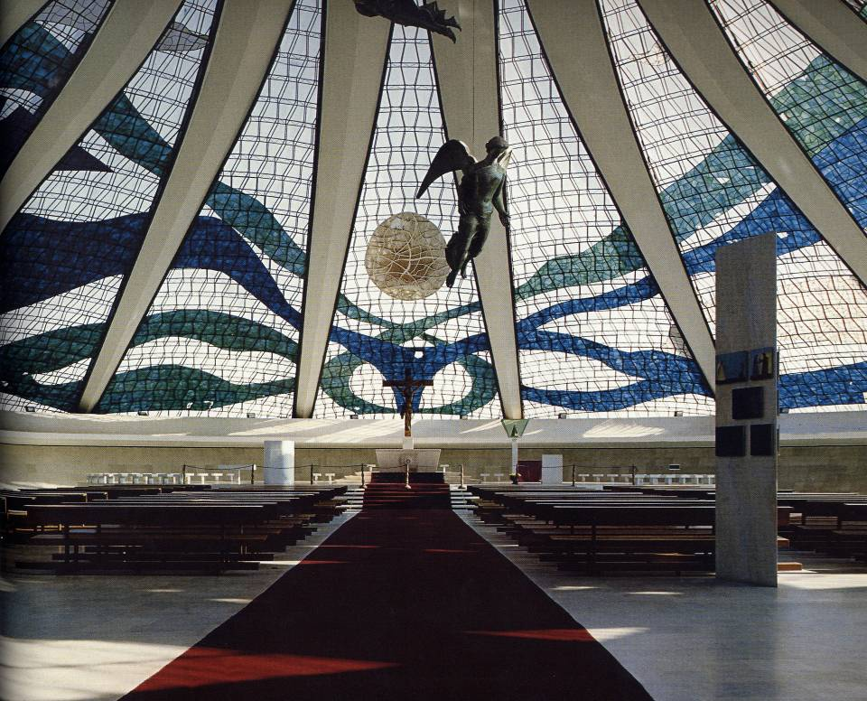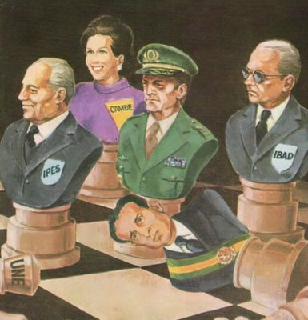
How did Brazil transform itself from a slave society in 1888 to a rising international economic and political force? This course will examine the history of Brazil from the end of slavery to the present. We will analyze the reasons for the fall of the Empire and the establishment of a republic, the transformations that took place as immigrants arrived from Europe, Japan, and the Middle East in the early twentieth century, and the search for new forms of national identity. We will study the establishment of an authoritarian regime in the late 1930s, the emergence of a nationalist/populist political movement of the 1950s and early 1960s, and the consolidation of a military dictatorship from 1964 to 1985. We will analyze the return to democratic governance in more recent years, and looks at the ways in Brazil has become an economic powerhouse, a leader in the Global South, and an emergent world power.

Required Reading
The following books are available at the Brown Bookstore:

Levine, Robert M. Vale of Tears: Revisiting the Canudos Massacre in Northeastern Brazil, 1893-1897. Berkeley: University of California Press, 1992.

Love, Joseph L. The Revolt of the Whip. Stanford: Stanford University Press, 2012.

Amado, Jorge. The Violent Land. New York: Penguin Classics, 2013.

Garfield, Seth. Indigenous Struggle at the Heart of Brazil: State Policy, Frontier Expansion, and the Xavante Indians, 1937-1988. Durham: Duke University Press, 2001.
D’Avila Jerry. Hotel Trópico: Brazil and the Challenge of African Decolonization, 1950-1980. Durham and London: Duke University Press, 2010.
Sattamini, Lina. A Mother’s Cry: A Memoir of Politics, Prison, and Torture. Durham: Duke University Press, 2010.

A selection of primary documents will be on the Canvas course website.

Course Expectation:
- Readings. You will be required to read on the average 125 pages a week. All assigned readings are required and should be completed before the lecture or discussion section.
- Attendance. Classroom attendance is mandatory. You cannot get an “A” unless you attend all lectures and discussion sections. I will be taking attendance in class.
- Written assignments. All assignments must be turned in electronically on the date and time indicated on the syllabus, or they will be considered late and your grade will drop. All papers should have an original title and be in a standard format (12 pt. font, 1” margins, double spaced, numbered, with appropriate citation and bibliography). Plagiarism is unacceptable and will be reported to the Dean of the College. If you have any questions about the Brown Academic Code, see: http://www.brown.edu/Administration/Dean_of_the_College/academic_code/guides.html
- Classroom discussion sessions. All students must participate in the discussion section. You should come prepared, having completed all of the reading and reviewed the study questions.

Course Assessment:
1. 20% Map quiz, attendance, and participation in discussion
2. 10% Paper #1: Five-page paper on a book about Brazil 1889-1945
3. 10% Reflections on two lectures
4. 10% Reflections on two films
5. 20% Midterm
6. 10% Paper #2: Five-page paper on A Mother’s Cry and a film about the dictatorship
7. 20% Final

- Map Quiz. The quiz will be based on a handout attached to the syllabus. As mentioned above, I will be taking attendance, and this part of your grade will be based in part on your active participation in the discussion sections.
- Paper #1. You will choose a scholarly book about Brazilian history that covers the period between 1889 and 1945. (The book may cover a broader period). In your five-page essay (original title, 12 pt. font, double-spaced, page numbers) you will analyze the author’s main arguments, how s/he presents them, and their relationship to an overall understanding of Brazilian history of the early twentieth century. Rather than merely summarizing the book, you should discuss its underlying content. If the book is not on the Suggested Bibliography posted on the website, please confirm your selection with me. The paper is due on Wed., Oct. 8 at 9 p.m.
- Reflections on two Brazil Initiative Lectures. You must attend two events about Brazil organized by the Brazil Initiative and write two one-page reflections about them. The first reflection is due on Fri., Oct. 10 at 9 p.m.; the second is due on Mon., Dec. 8 at 9 p.m. They will be graded pass/fail.
- Reflections on Two Films shown at the CineBrasil Film Festival. You will attend two films presented at the CineBrasil Film Festival that will be held Wed., Oct. 15 to Fri., Oct. 17 and write two one-page reflections on the films. Do not summarize the film plot but analyze the films as they reflect insights into Brazilian society and culture. They will be graded pass/fail. The two reflections are due on Mon., Oct. 20 at 9 p.m.
- Midterm exam. The in-class exam will cover the material from 1870 to 1937 and will be based on readings, documents, and lectures.
- Paper #2. This essay should be based on your reading of A Mother’s Cry and the outside classroom viewing of a film on the military dictatorship. (See film listing at the end of the syllabus). As in the first paper, it should be not merely summarize the book and the film but critically analyze them to consider what they tell us about the military regime. The essay should be five-pages, 12 pt. font, double-spaced, with an original title and page numbering. The essay is due on Fri., Dec. 5 at 9 p.m.
- Final exam. The final exam will cover material from the entire course and will be based on readings, documents, and lectures. You may take the exam on Tues., Dec. 9th or Fri., Dec. 19th.

COURSE SCHEDULE

Week #1 Introduction to the Course

Thurs., Sept. 4 Lecture #1: Is Brazil the Country of the Future?
Review of the Syllabus
Doc. #1: Map of Brazil

Week #2 The Decline of the Empire, 1870-89
Tues, Sept. 9 Lecture #2: Pedro II, Coffee, and the Paraguayan War,
Doc. #2: The Republican Manifesto (1870)

Thurs., Sept. 11 Lecture #3: Slavery, Abolition, and Its Aftermath

Doc. #3: Selections from Abolitionism (1883) by Joaquim Nabuco
Week #3 A New Republican Order

Tues., Sept. 16 Lecture #4: Republicanism and its Discontents
Doc. #4: Os Sertões (1902) by Euclides da Cunha
Thurs., Sept. 18 Discussion Section No. 1: Robert Levine, Vale of Tears (entire book)

Week #4 Radical Changes in Brazilian Society

Tues., Sept. 23 Lecture #5: The Immigration Tide
Doc. #5: On the Mestizo in Brazil (1911) by João Batista Lacerda

Thurs., Sept. 25 Lecture #6: Reconfiguring Gender Roles
Doc. #6: Early Brazilian Feminism (1873) by Francisca Senhorinha da Motta Diniz
Week #5 Urban Uprisings and Labor Organizing

Tues., Sept. 30 Lecture #7: The Forging of an Urban Working Class
Doc. #7: Demands of the São Paulo General Strike of 1917
Thurs., Oct. 2 Discussion Section No. 2: Joseph Love, Revolt of the Whip (entire book)

Week #6 Creating New National and Regional Identities.

Tues., Oct. 7 Lecture #8: Art and Modernism
Doc. #8: The Cannibalist Manifesto (Manifesto Antropófago) by Oswald de Andrade

Wed., Oct. 8: Paper #1 due at 9 p.m. Send a copy to James_Green@brown.edu and
Isadora_Mota@brown.edu

Thurs., Oct. 9 Lecture #9: Northeast vs. Southeast
Doc. #9: Document #12A The Masters and the Slaves (1933) by Gilberto Freyre
Fri., Oct.10 Reflection #1 on Brazil Initiative Event No. 1 due at 9:00 pm.

Week #7 The End of An Era

Tues., Oct. 14 Lecture #10: Critics of the Established Regimes
Doc. #10: Revolutionary Manifestos from the Tenentes Revolt (1924)
Wed., Oct. 15 to
Fri. Oct. 17 CineBrasil Film Festival

Thurs., Oct. 16 Discussion Section No. 3: Jorge Amada, The Violent Land (entire book)

Week #8 Vargas in Power

Mon., Oct. 20 CineBrasil Film Festival Reflections due at 9:00 pm

Tues., Oct. 21 Lecture #11: Getúlio Vargas and a New Order, 1930-1937
Doc. #11: From the Platform of the Liberal Alliance (1929)
Thurs, Oct. 23 Midterm Exam

Week #9 Vargas and Authoritarian Rule

Tues., Oct. 28 Lecture #12: The Estado Novo and World War II, 1938-45
Doc. #12: Vargas and the Estado Novo (1938)
Thurs., Oct. 30 Discussion Section No. 4: Seth Garfield, Indigenous Struggle at the Heart of Brazil (entire book)

Week #10 An Experiment in Democracy

Tues. Nov. 4 Lecture #13: Post-war Nationalism and Populism, 1946-54
Doc. #13: Vargas’s Suicide Letter (1954)

Thurs., Nov. 6 Lecture #14: Brasília and Bossa Nova: The Optimism of the Late 1950s
Doc. #14: Operation Pan America (1958) by Jucelino Kubitschek
Week #11 The Return to Authoritarian Governance

Tues. Nov. 11 Lecture #15: From Radical Populism to a Military Dictatorship
Doc. #15: Institutional Act (1964)

Thurs., Nov. 13 Discussion Section No. 5: Jerry D’Avila, Hotel Trópico (entire book)

Week #12 From Dictatorship to Democracy

Tues. Nov. 18 Lecture #16: The “Economic Miracle” and the Defeat of the Guerrillas
Doc. #16: The Kidnapping of the U.S. Ambassador (1969)
Thurs. Nov. 20 Lecture #17: The Slow-motion Transition to Democracy, 1979-88
Doc. #17: The Movement for Political Amnesty (1975-79)
Week #13 Cinematic Representations of the Military Regime

Tues., Nov. 25 Film viewing on the Brazilian dictatorship (see selections below)

Thurs., Nov. 27 No Class—Thanksgiving

Week #14 Democracy from the Right to the Left

Tues., Dec. 2 Lecture #18: Economic Chaos, a Constitution, and a New Economic Plan
Doc. #18: The Evolving Ideas of a Politician

Thurs., Dec. 4 Lecture #19: The Workers’ Party in Power
Doc. #19: Music, Culture and Globalization (2005)
Friday, Dec. 5 Paper #2: A Mother’s Cry/Film on the Dictatorship due at 9:00 p.m.
Week #15

Mon., Dec. 8 Brazil Initiative Event #2 Reflection due at 9:00 p.m.

Tues., Dec. 9 Exam Option #1
2:30-5:30
Fri. Dec. 19 Exam Option #2
9:00-12:00

Films on the Brazilian Dictatorship
Bautismo de sangue
Brazil: A Report on Torture
Ceu aberto
The Day that Lasted 21 Years
Diário de um busca
Four Days in September
Vlado: Thirty Years Later
Topografia de um desnudo
The Year My Parents Went on Vacation
Zuzu Angel

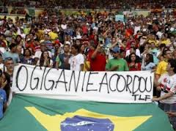
“The Giant has awakened,” June 2013 demonstrations.
Map of Brazil

