ENGL1910E Spring14 S01
Lyric Language and Form: Renaissance to Modern
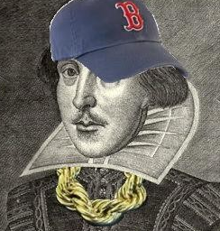
Tracing the trajectory of literary forms from the renaissance into the modern, we will look at stubborn forms like the sonnet (Shakespeare, Berryman, Lowell); soft forms like blank/free verse (Marlowe, Milton, Wordsworth, Tennyson, Eliot); low and nonsense forms (Skelton, Caroll, hip-hop); and the differing and sometimes antithetic functions of stanza line, and narrative (Spenser, Browning/Tennyson, Dr. Suess).
On a week to week basis, a changing array of poets largely from online sources will supplement readings from anthologies of renaissance poetry and provide the variables for weekly critiques, paraphrases, interpretations, imitations of 500 words shared in an ongoing class journal through the Discussions pages. (Students may claim two exemptions for these weekly written assignments.)
This growing list of readings will be shaped in process by student explorations of poetry and criticism. Consultation of standard resources like the online Princeton Encyclopedia of Poetry and Poetics will be routine.
A final interpretive exercise of 5000 words will complete student work for the course.
Weeks One and Two: Sonnets and Odes
Weeks Three and Four: Elegies and Epitaphs
Weeks Five and Six: Epigrams, satires, and epistles
Week Seven and Eight: Low forms
Week Nine and Ten: Blank verse
Weeks Eleven and Twelve: Stanza, line, and narrative

Texts Poetry Online

