JUDS 1711-S01

Spring 2014

Professor Rachel Rojanski

Rachel_Rojanski@Brown.edu
Monday 3:00-5:20
Office Hour: Thursday 1:00-2:15

History of the State of Israel - 1948 to the Present
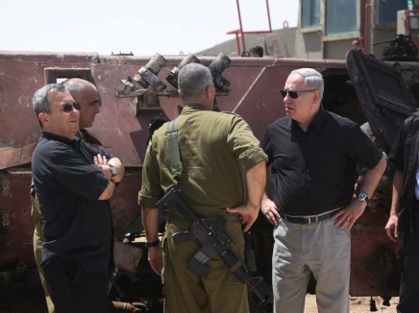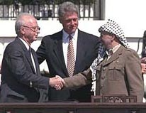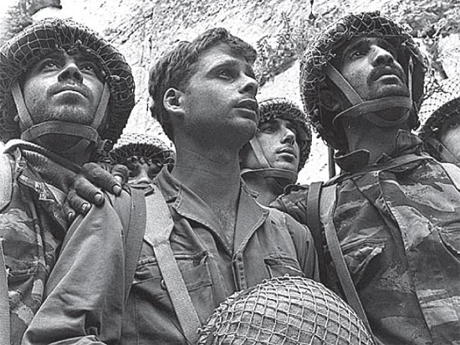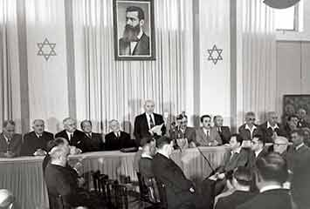

Course Description

This course will survey the history of Israel from the 1948 Proclamation of Independence until today. Israel's history has unfolded under the shadow of its prolonged conflict with the Palestinians and its Arab neighbors. At the same time, an entirely new, vibrant and dynamic society and culture has developed there, making Israel a strong Western influence in the Middle East.
The goal of this course is to familiarize the student with the major outlines of Israel's development, as well as the different narratives and interpretations of that history and issues connected to the historiography of this troubled region. The reading materials and class discussions in this course will examine not only the course of the Israeli-Arab conflict, but also its influence on domestic Israeli politics, culture, and society.

.

Reading List

Itamar Rabinowitz &Jehuda Reinhartz, Israel in the Middle East, Documents and Readings on Society, Politics, and Foreign Relations, Pre-1948 to the Present, Brandeis University Press, Waltham Ma, 2008.

Allan Dowty, A Jewish State, A Century Later, University of California Press, Berkeley and LA, 1998.

Colin Shindler, A History of Modern Israel, Cambridge, 2008

Anita Shapira, Israel: A History, Brandeis University Press, 2012.

The books are available at the Brown bookstore, The book by Anita Shapira is also available for Kindle. However you don’t have to buy anything. All the books are in the library on reserves.

On-line course pack of required readings. Our password is: Israel

Requirements:

1) Reading: All reading is required. .

2) Class Preparation:
This course is a lecture course. This means that most lecture sessions will draw directly on the reading for the day. Students are encouraged to participate in discussions and to ask questions. Please come prepared to class.

3) Written Assignments and Calendar of Submission

This is a WRIT course. Over the semester, students will have to submit three papers: Two short ones on Israeli leaders and a longer final paper. The focus of the short papers should be on the leadership of each of the leaders during the chronological period discussed in class. In the papers, students will have to integrate the knowledge and understanding they have acquired during class with additional readings. Each topic in the list is followed by one basic book. Students must consult the professor for some additional reading.
The third paper is an independent paper on any topic relevant to the class. Students should consult the professor before choosing a topic.

Paper #1 A short essay (1500 words) on David Ben-Gurion as Prime Minister (1948-1954;1955-1963).
Reading: Michael Bar-Zohar, Ben-Gurion: A Biography, New York, Adama Books,1986.

Question: How did Ben-Gurion’s leadership shape Israeli society during the 1950s? (Focus on one aspect: defense, society, or economics)

Paper due: February 24 , at 5:00PM

Paper #2 A short essay ( 1500 words) on Menahem Begin as Prime Minister (1977-1983).
Reading: Eric Silver (1984) Begin: The Haunted Prophet, New York, Random House, 1984.

Question: What was the impact of Begin’s leadership on Israeli Society in the 1970s and 80s? (Choose one aspect from the following: The Transition from Socialism to Capitalism, The Peace Process with Egypt, or the First Lebanon War).

Paper due: March 31, at 5PM

Paper #3 – Final paper A longer essay (3500 words) on any of the topics discussed in class. Students will meet with the professor, select a topic, find the readings and submit the paper –outline to the professor.

Schedule for paper#3:

Topic selection and preliminary bibliography: April 15

Individual discussion of paper with the professor the paper and a rough outline - no later than April 24

Draft submission (recommended) – April 30

Paper due: May 10, at 5PM

Grading:

Attendance and participation: 20%

Three Papers: 80%
Paper#1 -20%
Paper #2 - 25%
Paper #3( Final Paper) -35%

Weekly Schedule
Part I: The Formative Decades - 1948-1967

January 27 : Introduction: From Herzl to the Balfour Declaration

Sources:
Theodor Herzl, “A Solution of the Jewish Question”, January 17, 1896, Itamar Rabinowitz & Jehuda Reinhartz, Israel in the Middle East, Documents and Readings on Society, Politics, and Foreign Relations, Pre 1948 to the Present, Brandeis University Press, Waltham Ma, 2008, pp.16-20.
The First Zionist Congress, “The Basle Program, ” August 31, 1897, Rabinowitz & Reinhartz, p. 21.
Lord Balfour, “The Balfour Declaration”, November 2, 1917, Rabinowitz & Reinhartz , pp. 21; 29.

Reading
Anita Shapira. Israel A History, Brandeis University Press, 2012, pp. 1-67.
Shlomo Avineri, The Making of Modern Zionism, Basic book 1981, pp. 88-100.

February 3 : The “Yishuv” (Pre-State Israel): A Jewish State Before the State

Source:
Malcolm MacDonald, “White Paper”, May 17, 1939, Rabinowitz & Reinhartz, pp. 48-53

Reading:
Tom Segev, One Palestine, Complete, Jews and Arabs Under British Mandate, Metropolis Book 2000, pp. 447-511
Shapira, Israel A History, pp. 103-133.

February 10: Building a Nation

Source:
United Nations General Assembly, “Resolution 181,” November 29, 1947, Rabinowitz & Reinhartz, pp. 61-62.
“The Proclamation of the State of Israel”, May 14, 1948, Rabinowitz & Reinhartz, pp.72-73

Reading:
Dan Horowitz and Moshe Lissak, Origins of Israeli Polity: Palestine under the Mandate. Chicago, University of Chicago Press, 1987. pp. 187-213
Dan Horowitz and Moshe Lissak, Trouble in Utopia: the Overburdened Polity of Israel, Albany: SUNY Press, pp. 1-31.
Shapira, History of Israel pp. 179-222

February 17: No Class - long weekend

February 24: The Mass Immigration and the Absorption of the Immigrants. (“Aliya”)

Paper #1 due today, 5pm

Sources:
“The Law of Return”, July 5, 1950, Rabinowitz &Reinhartz, pp. 102-103.
Giora Josephtal, “The Absorption of Immigrants”, August 1951, Rabinowitz & Reinhartz, pp. 103-105

Reading:
Shapira, Israel – A History, pp. 222-248.
Moshe Lissak, “The Demographic-Social Revolution in Israel in the 1950s: The Absorption of the Great ‘Aliya’”, Journal of Israeli History, 22,2 (2003), pp. 1-31
Dvora Hacohen, Immigrants in Turmoil, Syracuse University Press, 2003, pp. 12-94.

March 3: Social Tensions – Israeli Ethnicity and the Arab Minority 1950-1960

Source:
David Ben-Gurion “Social and Ethnic Tension in Wadi Salib”, Rabinowitz & Reinhartz, pp. 164-166.
Azmi Bishara, “Arab Citizens of Palestine: Little to Celebrate”, Rabinowitz & Reinhartz, pp. 467-468.

Reading:
Colin Shindler, pp. 91-97
Emmanuel Marx, “The Development Town, 1956-1966: Analysis “ in: Rabinowitz & Reinhartz pp. 158-163.
Alan Dowty, The Jewish State, A Century Later, University of California Press, Berkeley and LA, 1998, pp. 184-215.
Tom Segev, 1949: The First Israelis, 43-67

Watch the movie “Salah Shabbati” (Access will be explained in class)

Part II: War, Euphoria, and War Again – 1967-1982

March 10: The 1967 War and its Impact on Israeli Society
Reading:
Tom Segev, 1967, Israel, the War, and the Year that Transformed the Middle East, Metropolitan Books, New-York, 2007, pp. 419-481. 500-522
Colin Shindler, pp.123-146.
Shapira, Israel A History, pp. 295-326

Watch the movie “Late Summer Blues” (OCRA)

March 17: The 1973 War

Reading:

Benny Morris, Righteous Victims ,Vintage, 2001, pp. 387-444.
Shapira, pp. 326-340

March 24: Spring Break

March 31: 1977 – “The Upheaval” in Israeli Politics

Paper #2 due today, 5pm

Source:
Menahem Begin, “Prospects for the New Government, May 19-20 1977, in: Rabinowitz & Reinhartz, pp. 296-300.

Reading:
Colin Shindler, pp. 123-150.
Ehud Sprinzak, The Ascendance of Israel’s Radical Right, Oxford UP, 1991, 35-51, 61-105
Shapira, pp. 357-391.

.

April 7: Israeli Society - The Gap Between Right and Left and the Changes in Israeli Identity

Sources:
Gush Emunim, “Opinion Paper”, January 1978, Rabinowitz & Reinhartz, pp. 305-307.
Peace Now, “Platform”, 1980, Rabinowitz & Reinhartz, pp. 312-314.

Reading:
David Newman, “A Comparative Study of Gush Emunim and Peace Now”, Middle Eastern Studies, 28, 3 (1992), pp. 509-530.
Shapira, pp. 391-422.
.

April 14: No Class- Passover (make up class on April 28)

Part III: War, Hopes for Peace, and Changes in Israeli Society 1982-2012

April 21 : 1982 War and Israeli Society

Source:
Amos Oz, “On Behalf of Pluralism”, December 1982, Rabinowitz & Reinhartz, pp. 412-414.

Reading:
Colin Shindler, pp.175-197
Eyal Zisser, “The 1982 "Peace of Galillee" War: Looking Back in Anger”in Bar-On, A Never-Ending Conflict, pp. 194-210

Watch the Movie: Waltz with Bashir (OCRA)

April 28: The “Oslo Accord and the Assassination of Yitzhak Rabin and Israeli Society

Source:
Yitzhak Rabin, “Speech to the Knesset on the 1992 Elections, July 13, 1992, in:
Rabinowitz & Reinhartz, pp. 446-449.
Shamgar Commission , “Report on Yitzhak Rabin’s Assassination”, 1996, in:
Rabinowitz & Reinhartz, pp. 456-458.

Reading:
Colin Shindler, pp227-236.
Amnon Rubinstein, “Toward Rabin’s Assassination,” From Herzl to Rabin, 111-158
Yoram Peri, “The Assassination: Causes, Meaning, Outcomes” in: Yoram Peri (ed.), The Assassination of Yitzhak Rabin, Stanford, Stanford University Press, 2000, pp. 25-62.
Shapira, pp. 422-460

April 30: After Rabin: The Run-up to the Second Lebanon War (2006)
Sources
Rabinowitz & Reinhartz, pp533-537;543-544;553-555

Reading:.
Colin Shindler, pp. 267-320.
Benny Morris, pp. 652-676

Final Paer due: May 10th

