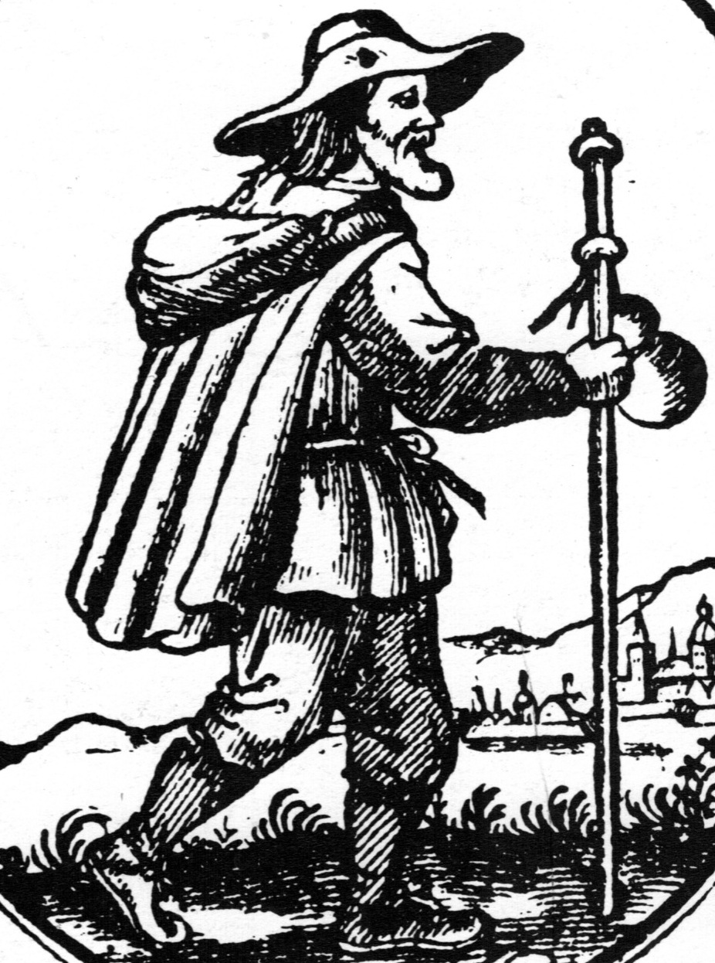

HIST 1976R S01
Early Modern Globalization: Jewish Economic Activity, 1500-1800
Spring 2014

Prof. Adam Teller
adam_teller@brown.edu

What can the experience of a minority group like the Jews teach us about the roots of globalization? What were the economic, political, and cultural conditions that allowed early modern Jewish merchants to create economic networks stretching from India to the New World? We will answer these questions by examining the connections and interactions between four major Jewish centers: Ottoman Jewry in the Eastern Mediterranean, the Port Jews of Amsterdam and London, Polish-Jewish estate managers in Ukraine, and the Court Jews of central Europe. We will see how European expansion exploited - and was exploited by - these Jewish entrepreneurs.
Over the course of the semester students will be expected to write three response papers (1,500-2,000 words each) on major monographs in the field. In addition, students will write a research paper (4,000-5,000 words) on a topic to be determined. It will be due by 5/20.

Each topic in the syllabus will be covered in the week. Classes will combine a frontal lecture with open discussions of the week’s readings and primary sources in English translation. Students will be expected to begin each week ready to discuss that week’s readings in class. Active participation in class discussions will form part of the final grade for the course.

No prior knowledge of Jewish, European or economic history is required.
Course Goals and Objectives
By introducing students to the basic themes of early modern Jewish economic history in the widest possible context, this course will :
- Situate the history of the Jews within a broader history of the early
modern world.
- Encourage reflection and critical comparison of a range of methodological
approaches to historical research in the fields not only of economic, but also of social and cultural history.
- Give the student the tools he or she needs to write a research paper in this
field.

By the end of the course, students should be able to:
- Identify the key issues in the study of early modern Jewish history,
particularly in the economic realm.
- Read and critically analyze historical writing on early modern economic
history from different schools of historical research.
- Write a research paper, identifying a suitable research question, and
constructing a logical argument to answer it based on a combination of primary and secondary sources.

Grading
- Class Participation 10%
- Three Response Papers: 20% each = 60%
- Research Paper 30%

Readings
All the readings for the course are scanned and can be found on OCRA: Course password:
EMG2014

Response Papers
The response papers are on the following books:

1. Francesca Trivellato, The Familiarity of Strangers: The Sephardic Diaspora, Livorno, and Cross-Cultural Trade in the Early Modern Period, New Haven 2009
Due Date: 2/20 -12:00pm

2. Werner Sombart, Jews and Modern Capitalism, Glencoe Ill. 1951
Due Date: 3/14 -12:00pm

3. Moshe Rosman, The Lords’ Jews: Magnate-Jewish Relations in the Polish-Lithuanian Commonwealth During the 18th Century, Cambridge Mass. 1990
Due Date: 4/4 -12:00pm

These books can all be purchased at the Brown Bookstore and will be put on reserve in the library.

The papers should be 1,500-2,000 words in length and should summarize the main arguments made in the study, showing how they are constructed and briefly pointing out major strengths and weaknesses.

Research Paper
One of the main goals of the course is to help students improve their skills in preparing and writing a research paper. We will devote a good deal of class discussion to this issue, examining it from a number of different viewpoints. I will provide students with a bibliography on which to base their research paper. Those who would prefer to write on a topic of their own choosing are encouraged to do so. I will meet with them separately to ensure that the topic is feasible, and to help them plan their work. All students are encouraged to contact me either by e-mail or during office hours to discuss their papers or any other issues arising from the course. Due Date: 5/20 – 5pm.

Contact
I can best be contacted by e-mail (adam_teller@brown.edu).
My office: #301 in the Jewish Studies building,
163 George St. (corner of Brook)
Office hours: Tuesdays and Thursdays, 11:00-12:00 (and by appointment)

TOPICS

1/27 1. Introduction: Networks, Global, Jewish, and Other

Reading:
- Albert-Laszlo Barabasi, Linked: The New Science of Networks, Cambridge
Mass. 2002, pp. 41-64, 199-217
- Dean Phillip Bell, Jews in the Early Modern World, Lanham 2008, pp. 35-92
Recommended Reading:
- Carlo M. Cipolla, Between Two Cultures: An Introduction to
Economic History, New York 1991, pp. 1-14

2/3 2. Settling Eastern Europe

Reading:
- Douglass C. North, Understanding the Process of Economic Change, Princeton
2005, pp. 1-80
- Adam Teller, “Jews in the Polish Lithuanian Economy, 1453-1795”
(Unpublished Manuscript. On Canvas)

2/10 3. Between East and West: Jewish Settlement in the Ottoman
Empire and in India
Reading:
- Walter Zenner, Minorities in the Middle: A Cross-Cultural Analysis, New
York 1995, xi-xv, 1-26
- Yaron ben Naeh, Jews in the Realm of the Sultans, Tubingen 2008, pp. 318-
350

2/17 No Classes

2/20 First Response Paper Due: 12:00pm

2/24 4. Micro-Networks and Macro-Networks in Early Modern
Italy
Reading:
- Stefanie Siegmund, The Medici State and the Ghetto of Florence: The
Construction of an Early Modern Community, Stanford 2006, pp. 292-331
- Benjamin Arbel, “Jews in International Trade: The Emergence of the
Levantines and the Ponentines”, in: R. Davis, B. Ravid (eds.), The Jews of
Early Modern Venice, Baltimore 2001, pp. 73-96

3/3 5. The Jews and the Atlantic Economy

Reading:
- Jonathan Israel, “The Sephardi Contribution to Economic Life and
Colonization in Europe and the New World (16th-18th Centuries)”, in:
Haim Beinart (ed.), Moreshet Sepharad: The Sephardi Legacy, II, Jerusalem
1992, pp. 365-398
- Seymour Drescher, “Jews and New Christians in the Atlantic Slave Trade”,
in: P. Bernardini, N. Fiering (eds.), The Jews and the Expansion of Europe to
the West, New York-Oxford 2001, pp. 439-470

3/10 6. In the New World

Reading:
- Jonathan Israel, Diasporas within a Diaspora: Jews, Crypto-Jews and the World
Maritime Empires (1540-1740), Leiden 2002, pp. 97-123
- Eli Faber, A Time for Planting: The First Migration, 1654-1820, Baltimore
1995, pp. 4-51

3/14 Second Response Paper Due: 12:00pm

3/17 7. Religion and Economy

Reading:
- Max Weber, The Protestant Ethic and the Spirit of Capitalism, New York 1958,
48-78, 155-183, 192-204, 258-284

3/24 Spring Break: No Classes

3/31 8. Jewish Women’s Economic Activity

Reading:
- Natalie Zemon Davis, Women on the Margins: Three Seventeenth-Century
Lives, Cambridge Mass. 1997, pp. 5-62

4/4 Third Response Paper Due: 12:00pm

4/7 9. Polish-Lithuanian Jewry in the Service of the Magnates
Reading:
- Gershon D. Hundert, The Jews in a Polish Private Town: The Case of Opatów
in the Eighteenth Century, Baltimore 1991, pp. 46-68
- Moshe Rosman, The Lords’ Jews: Magnate-Jewish Relations in the Polish-
Lithuanian Commonwealth During the 18th Century, Cambridge Mass. 1990, pp. 106-142

4/14, 4/21 No Classes: Jewish Holiday

4/17, 4/24 Consultations on Final Papers

4/28 10. The Court Jews of the Holy Roman Empire: Center of the Jewish
Global Economy
Reading:
- Jonathan Israel, European Jewry in the Age of Mercantilism, London 1998, pp.
101-118
- Selma Stern, The Court Jew, Philadelphia 1950, pp. 15-60

5/5 11. Issues of Reform: Debates on the ‘Jewish Question’: London,
Paris, and Warsaw, 1753-1792
Reading:
- Gershon D. Hundert, Jews in Poland-Lithuania in the Eighteenth Century: A
Genealogy of Modernity, Berkeley 2004, pp. 211-231
- Arthur Hertzberg, The French Enlightenment and the Jews, New York 1968,
pp.

5/20 Research Paper Due: 5:00pm

