JUDS 1713-S01

Spring 2014

Professor Rachel Rojanski

Rachel_Rojanski@Brown.edu
Thurthsday 4-6:20PM
Office hour: Thursday 1:00-2:15PM

Introduction to Modern Yiddish Culture and Language

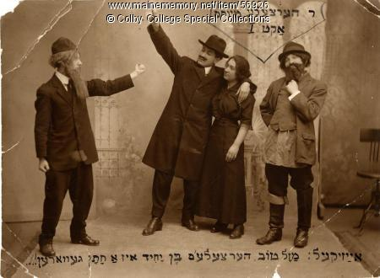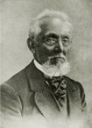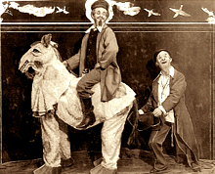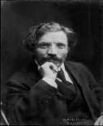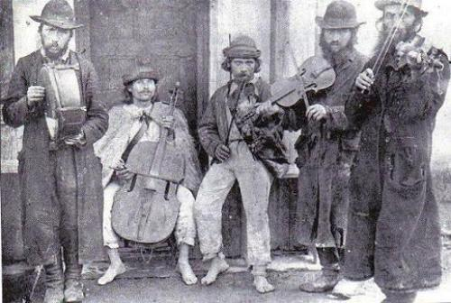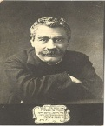

Yiddish was the language spoken by most Jews in Eastern Europe and the countries to which they emigrated (including the US, England, South Africa, South American countries, and Israel) from the nineteenth century until after the Holocaust. It was the basis for a transnational Jewish culture and literature, and played a central role in modern Jewish political life. We will explore the history of Yiddish culture and the development of the Yiddish press, literature, theater and cinema. The connection between Yiddish and modern Jewish politics will also be discussed.

Students who wish to learn some basic Yiddish language during the course, will have the opportunity to do so.

Reading List
Students will be expected to use the following books in addition to the weekly readings, especially as sources for papers:

- Ruth Wisse, (Ed. and translator), The Y. L. Peretz Reader, Yale University Press, 2002.

-Dan Miron (Translator), Tevye the Dairy Man and the Railroad Stories, Penguin Books, 2009.

- Dan Miron & Ken Friden (Eds.) The Tales of Mendele The Book Peddler. S. Y. Abramovitsh.
New–York , 1996.

In addition, there are books on reserve in the library for your projects and a course pack of selected readings on OCRA

The class password for OCRA is Yiddish

Requirements:

This course has two tracks. Each one has different assignments.

Track A: Without a language component. This follows the weekly schedule given below.

Track B: With Yiddish language classes. This includes both the weekly schedule and weekly section in Yiddish language. To compensate, this track has its own requirements for assignments and grading. See below

1) Reading: All reading is required. The books are available at the Brown Bookstore. Copies are also on reserve in the library. Selected readings will be available on OCRA.

2) Class Preparation: This course is designed as a seminar. This means lectures will be combined with discussions of the assigned readings. Please come prepared to discuss and analyze these readings.

3) Written Assignments and Calendar of Submission *Track A*

Over the semester, students who choose Track A will have to submit two short papers, with one, longer final research paper due at the end.

Paper #1 will be a short essay (1500 words) on the early development of Yiddish language.
Paper due: Feb. 20

Paper #2: A short essay (2000 words) on one of the Yiddish classics, chosen by you.
Paper due: April 3

Final Paper: A fifteen-twenty page research paper on an aspect of Yiddish culture that you would like to explore in further depth. The paper will be based on primary and secondary sources.
Paper due: May 5

Topics and bibliographies for the papers must be approved by the professor no later than a week before submission day. Papers that were not been approved will not be accepted.

3a. Written Assignments and Calendar of Submission – *Track B*

Students who choose Track B will attend a weekly section of language studies and will have to submit a short written language exercise each week. They will not need to submit paper #1 specified above.

Assignment #1:
Weekly language exercises.

Due: On a weekly schedule as explained in class.

Assignment #2: A short essay (1500 words) on one of the Yiddish classics, chosen by you.
Paper due: April 3

Final Paper: A fifteen-twenty page research paper on an aspect of Yiddish culture that you would like to explore in further depth. The paper will be based on primary and secondary sources.
Paper due: May 5

Grading

The final grade will be made up as follows:
Track A
Class participation and discussion: 16%
Paper #1 -22%
Paper #2- 27%
Final paper – 35%

Track B
Class participation and discussion: 16%
Weekly language exercises -24%
Assignment # 2- 25%
Final paper – 35%

Weekly Schedule:
`
Jan. 23: Introduction
Reading:
Benjamin Harshav, The meaning of Yiddish, University of California Press, Berkeley , 1990 .pp. 3-89.

January 30: Early Written Yiddish Culture and the Role of Women in its Development

Reading:

Alicia Ramos-González, “Women in Yiddish Culture in the
16th–18th Centuries, European Journal of Women’s Studies , 2005 , Vol. 12(2) pp. 213–226

Chava Weissler "For Women and for Men Who Are like Women": The Construction of Gender in Yiddish Devotional Literature”, Journal of Feminist Studies in Religion, Vol. 5, No. 2 (Fall, 1989), pp. 7-24

Chava Weissler ,” Woman as High Priest: A Kabbalistic Prayer in Yiddish for Lighting Sabbath Candles”, Jewish History, Vol. 5, No. 1 (Spring, 1991), pp. 9-26

Chava Weissler, “Women's Studies and Women's Prayers: Reconstructing the Religious History of Ashkenazic Women”, Jewish Social Studies, New Series, Vol. 1, No. 2 (Winter, 1995), pp. 28-47.

Feb. 6: The Beginning of Modern Yiddish: The Yiddish Press

Reading:
Alexander Orbach, New Voices of Russian Jewry: A Story of the Russian-Jewish Press of Odessa in the Era of Great Reforms, Leiden, Brill, pp. 95-124, 155-182, 196-207.
Kalman Weiser, “A Tale of Two Priluckis: The Origins of the Warsaw Yiddish Press”, Gal-ed 22, 2010, pp. 89-117.

Feb 13: The Beginning of Yiddish Theater

Reading:
Nahma Sandrow, , A World History of Yiddish Theater,Syracuse University Press, 1997, pp: 1-132

February 20: The Classics of Yiddish Literature I: Mendele The Book Paddler (Mendele Moykher Sforim)

Paper #1 due today BY 5PM

Reading:
S. Y. Abramovitsh (Mendele Moykher Sforim), “The Little Man”,in: Ken Frieden, Classic Yiddish Stories, Syracuse 2004, pp. 3-31.
S. Y. Abramovitsh (Mendele Moykher Sforim) “Fishke the Lame”, in: Ken Frieden, Classic Yiddish Stories, Syracuse 2004, pp.32-54.
Dan Miron, A Traveler Disguised : The Rise of Modern Yiddish Fiction in the Nineteenth Century, Syracuse University Press, 1996 (2nd edition), pp. 1-66.

February 27-March 6: The Classics of Yiddish Literature II: Sholem Aleichem

Reading:
Dan Miron, “Sholem Aleichem, Person, Persona, Presence” in: The image of the Shtetl and other studies of Modern Jewish Literary imagination, Syracuse 2000, pp. 128-156.
Sholem Aleichem, Tevye the Dairyman, Pinguin Books, 2009, pp. 3-115.
Sholem Aleichem, Motl the cantor’s Son, Pinguin Books, 2009, pp. 137-185,213-245,275-294,337-346.
David Roskies, “Sholem Aleichem and Others: Laughing off the Trauma of History”, Prooftexts 2/1 (1982): 53-77.

March 13 : The Classics of Yiddish Literature III: Y. L. Peretz

I.L. Peretz, “Between two Mountains”, in : Ruth Wisse The I.L. Peretz Reader, pp. 184-195.
I.L. Peretz, “If not Higher”, in : Ruth Wisse The I.L. Peretz Reader, pp. 178-180
I.L. Peretz, “The Pious Cat”, : Ruth Wisse The I.L. Peretz Reader, pp. 128-129.
I.L. Peretz, “Bontsh Shvayg” (Bontshe the Silent) in: Ruth Wisse The I.L. Peretz Reader, pp. 146-152
Ruth Wisse, Y. L, Peretz and the Making of Modern Jewish Culture, University of Washington Press, 1991, pp. 3-110.

March 20: Yiddish, Modern Jewish Politics and Jewish Nationalism

Reading:
David E. Fishman, The Rise of Modern Yiddish Culture, Pittsburgh Press, 2005 pp. 18-79.

Emanuel Goldsmith, Modern Yiddish Culture, NY,1987, pp.98-119; 183-220.

March 27 Spring Break

April 3 : Yiddish in Interwar Poland

Paper#2 due today by 5PM

Reading:
Chone Shmeruk, “Hebrew-Yiddish-Polish: A Trilingual Jewish Culture”’ in: Yisrael Gutman et al. (ed), The Jews of Poland Between two World Wars , Hanover &London,1989, pp.285-311
Avraham Novershtern, “Yung Vilne: The Political Digestion of Literature”, in: in: Yisrael Gutman et al. (ed), The Jews of Poland Between two World Wars , Hanover &London,1989, pp. 383-398.
Nathan Cohen, The Yiddish Press as Distributor of Literature, Modern Yiddish Literature, 2007, pp. 7-29
Lucy S. Dawidowicz, "Max Weinreich (1894-1969): The Scholarship of Yiddish" American Jewish Year Book 70 (1969) 59-68

April 10: Yiddish Film and theater in the 20th Century

Watch the film “Yidl mitn fidl” [Yidl with the Violin] on OCRA

Reading:
Walden, Joshua S. "Leaving Kazimierz: Comedy and Realism in the Yiddish Film Musical ‘Yidl Mitn Fidl’, Music, Sound, and the Moving Image , 3.2, (2009): 159-193.

Nahma Sandrow, , A World History of Yiddish Theater,Syracuse University Press, 1997, pp: 91-131; 203-221: 303-336.

April 17: Building Yiddish as an Academic Field

Reading:
Lucy S. Dawidowicz, "Max Weinreich (1894-1969): The Scholarship of Yiddish" American Jewish Year Book 70 (1969) 59-68
Barbara Kirshenblatt-Gimbeltt, “Coming to Age in the Thirties: Max Weinreich, Eduard Sapir, and Jewish Social Science”, Yivo Annual of Jewish Social Science 23 (1996): 1-103.
Dan Miron," Between Science and Faith: Sixty Years of the YIVO Institute", YIVO Annual 19 (1990), pp 1-15.

April 24: Yiddish in the Countries of Immigration: The USA and Israel
Reading:
Ruth R. Wisse , “Ups and Downs of Yiddish in America”, in Edward S. Shapiro, Yiddish in America, University of Scranton Press, 2008. pp. 1-22.
Irving Howe, The World of our Fathers, NY 2005, pp.417-451
Rachel Rojanski, “Yiddish in Israel 1948-1968”, Joseph Sherman, Yiddish After the Holocaust, Oxford, 2004, pp.46-60

Paper #3: due May 7 by 5PM

