Neuroscience: Axon Action Potentials Lab

Student Name:

Instructions:

- Save this document to your computer and rename it, LastName.FirstNameAction.doc

- Download and install the MetaNeuron simulation program from within the course or from the website, http://www.metaneuron.org. **Required information Institution Name, Course Name and MetaNeuron Version (Mac/Windows).

- Select Lesson 4: Axon Action Potential in the Lesson menu to view the lesson information.

- When you are finished with the worksheet, return to the course and upload your document by clicking “Submit Assignment” and following the prompts.

Part 1. Action potential threshold
Remember that if the membrane potential is depolarized beyond a certain point, known as threshold, then the cell will generate an action potential. Thus, if you inject a large amount of current into the cell, the faster the membrane potential will depolarize and the more likely the neuron is to fire an action potential. In contrast, with a smaller amount of current, them membrane potential will take longer to reach threshold, or maybe not even reach it at all. Let's examine the relationship between membrane depolarization and threshold.
First let's measure the action potential on the screen. You will make three measurements: the inflection point, the peak and the undershoot. The inflection point is when the action potential is triggered, the peak is the top of the action potential and the undershoot is the lowest point after the peak. (see below)
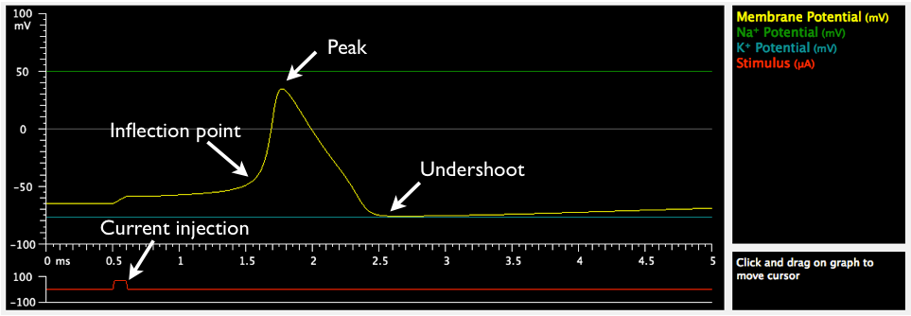

Step 1: If you click and drag on the yellow graph in MetaNeuron Lesson 4 you will see a measurement cursor. Use this cursor to measure the membrane potential (in millivolts, mV) and the time (in milliseconds, ms) for the inflection point, peak and undershoot, and write these down in a table:
 | Membrane Potential (mV) | Time (ms)
Inflection Point
Peak
Undershoot
Step 2: Now let's see what happens if we inject increasing amounts of current to the cell.
Find the window that says "Stimulus 1" and set the value of Amplitude to 25 and press enter (note the units are in micro amperes or µA, which are the units for electrical current). This reduces the amount current that you are injecting into your cell. You can see the reduction in current injected because the blip in the red line gets smaller.

1.2.1. What happens to the action potential?

1.2.2. Why do you think this happens?

Step 3: Now increase the amplitude of "Stimulus 1" to 45, 55, 65, 75, 100 and 200.
1.3.1. For each value, note what happens to the action potential:

1.3.2. Why do you think this happens?

1.3.3. What is the minimum amount of current you need to inject into your cell to trigger an action potential?

Step 4: Set the stimulus amplitude to 200 and perform the same set of measurements you did earlier, and enter these in a table:
 | Membrane Potential (mV) | Time (ms)
Inflection Point
Peak
Undershoot

1.4.1. How do the new values compare to the old values? What changed?

1.4.2. Threshold is the membrane potential value at which a depolarization triggers an action potential, and can be approximated by measuring the membrane potential at the inflection point. As you increase the amplitude of Stimulus 1, does the action potential threshold change? Why or why not?

The take home message here is that the more current you inject into your cell, the more the membrane potential is depolarized and the faster it reaches action potential threshold.

Part 2: Refractory Period
After a neuron fires an action potential, it is followed by an absolute refractory period during which it cannot generate another action potential and a relative refractory period, during which it is possible but more difficult to generate more action potentials. Let's measure the relative and absolute refractory periods.
Step 1: First find the box that says graph and set the sweep duration to 10 ms. Set the amplitude of Stimulus 1 to 200. In the box that says Stimulus 2, click the On check box, set the delay to 1 ms and amplitude to 200. Notice that the red line now has two blips, each representing a current injection into the cell.
2.1.1. Do both stimuli trigger an action potential?

Step 2: Now set the delay value of stimulus 2 to 2, 3 and 4 ms.
2.2.1. What is the shortest interval (delay) between stimuli that gives you a second action potential?

This is showing you the refractory period.
Step 3: Let's find out if this is the absolute or relative refractory period. Set the delay to 2 ms. If this is the relative refractory period, we should still be able to evoke an action potential if we depolarize the cell more. Increase the amplitude of the second stimulus to 250, 300, 350, 400.

2.3.1. Do any of these values evoke a second action potential?

2.3.2. What is different between the second and the first action potential?

Step 4: Now let's look at the absolute refractory period. Keep the amplitude of Stimulus 2 at 400 and set the delay value of Stimulus 2 to 1 ms.

2.4.1. What happened to the second action potential?

Step 5: Try increasing the amplitude of stimulus 2 as high as you want.
2.5.1. Can you evoke an action potential?

This is the absolute refractory period because no matter how much current you inject, you cannot evoke another action potential so soon after the first one.

Part 3: Sodium and the action potential.
When you reach threshold, you increase the chances that voltage gated Na channels open up, causing Na ions to rush into the cell and change the membrane potential toward the Na equilibrium potential (ENa). This is why the peak of the action potential is close to ENa.
What would happen if ENa were less positive; would you predict that the peak of the action potential to be shorter or taller?

Step 1: Turn off Stimulus 2, set the amplitude of Stimulus 1 to 150. Measure and enter in the table the time and membrane potential values for the inflection point, peak and undershoot:
 | Membrane Potential (mV) | Time (ms)
Inflection Point
Peak
Undershoot

Step 2: Now let's change ENa. In the box labeled Membrane Parameters, set the Na equilibrium potnetial to 0 mV and perform the same measurements:
 | Membrane Potential (mV) | Time (ms)
Inflection Point
Peak
Undershoot

3.2.1. What is different? Why you think this is?

3.2.2. What changes could you make to the Na concentration in the extracellular solution to cause ENa to become less positive?

Bonus: The rising phase action potential is mediated by Na entry into the neuron, the falling phase is due to K ions leaving the cell. In the box labeled Membrane Parameters, set the Na equilibrium potential to 50 mV and the K equilibrium potential to -95 mV.

1. What happens to the undershoot?

2. Why?

